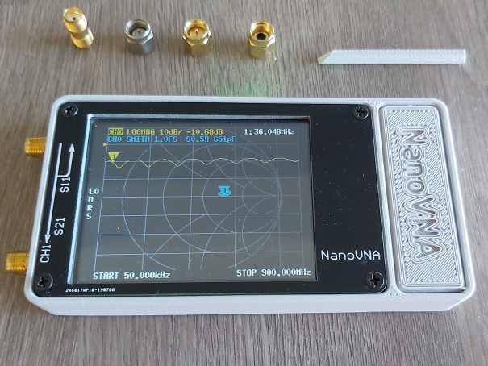
Instructions for SWR using a nanoVNA –
Compiled and revised by K5MFP & Friends
Suggestions
Use a soft-ended stylus for touching the screen for selection Menu choices. Don’t use a hard pointed device to select menu selections. This might damage the touch screen. Some prefer the stylus/touchscreen method or a finger.
It has been said that you should calibrate every time that you go to use the VNA, but you can save the calibration in memory. I have checked the same cable’s SWR on different days, and the calibration was correct all three times. When in doubt, calibrate each time you power it on to use it. The calibration slugs are small and easily dropped and very hard to find in the grass. Calibrate in a safe location.
If you save your calibration to a 0-4 memory location, it should hold the calibration in that memory location, unless you reset the VNA or lose battery power to it.
Do not press down on the 2 function thumb wheel. You can select the menus with this wheel, but it is easier to do it on the touch screen. The thumb wheel moves the SWR marker from left to right and back again.

To Calibrate your VNA
- Tap center right on screen for Menu
- Tap on Cal on Menu
- Tap Calibrate
- Connect the Open calibration slug and tap open
  - Open will turn dark and then remove the open slug
- Connect the Short calibration slug and tap short
  - Short will turn dark and then remove short slug
- Connect Load (50 ohm) calibration slug and tap load
  - Load will turn dark and then remove load slug
- Tap Done
- Tap Save 0 (0-4 memory locations)
- Tap Back
- Tap Done

To setup VNA Trace Lines (for displaying SWR and Smith Chart together or separately)
- Tap center right on screen for Menu
- Tap Display
- Tap Trace
- Tap Trace 0
  - (Yellow = SWR) or
  - Trace 1 (Blue = Smith Chart) to enable either On/Off
- Tap Back

To Setup the VNA Display (for viewing SWR on the display)
- Tap center right on screen for Menu
- Tap Display
- Tap Trace
  - Trace 0 is yellow (for SWR)
  - Trace 1 is blue (for Smith Chart)
  - Tap Back
To Setup the VNA Scale (for viewing SWR on the display)
- Tap Scale
- Tap Scale/DIV
- Tap on far right lower corner on white banner
  - This will display a keypad
  - Tap in 5.0, then tap X1
  - Tap Back
- Tap Reference Position
  - Tap lower right corner on white banner
  - Tap in 5.0, then tap X1
  - Tap Back
  - Tap Back again
To Setup VNA Stimulus (to set SWR Frequency Start/Stop range)
- Tap Stimulus
- Tap Start
  - Tap lower right bottom for keypad
- Tap in Frequency (example 14.150) then tap M
- Tap Stop
  - Tap lower right bottom for keypad
- Tap in Frequency (example 14.350) then tap M
- Tap Back
- Tap Close

To Read SWR
Place a finger to the left of the center point and gently rotate the thumb wheel to the right. This moves the yellow marker up and down the selected frequency range. It will show the SWR for whatever point on the frequency you stop. Placing your finger to the right of the center point and rotating the wheel moves the marker to the left. The SWR is the yellow x.xx number at the very top of the screen in the middle. Example: x.xx might be 1.19 to 1 SWR.

To Check SWR On Another Frequency

- Tap Back
- Tap Back again to Stimulus on Menu and repeat steps

A good resource is: nanovna-users@groups.io

